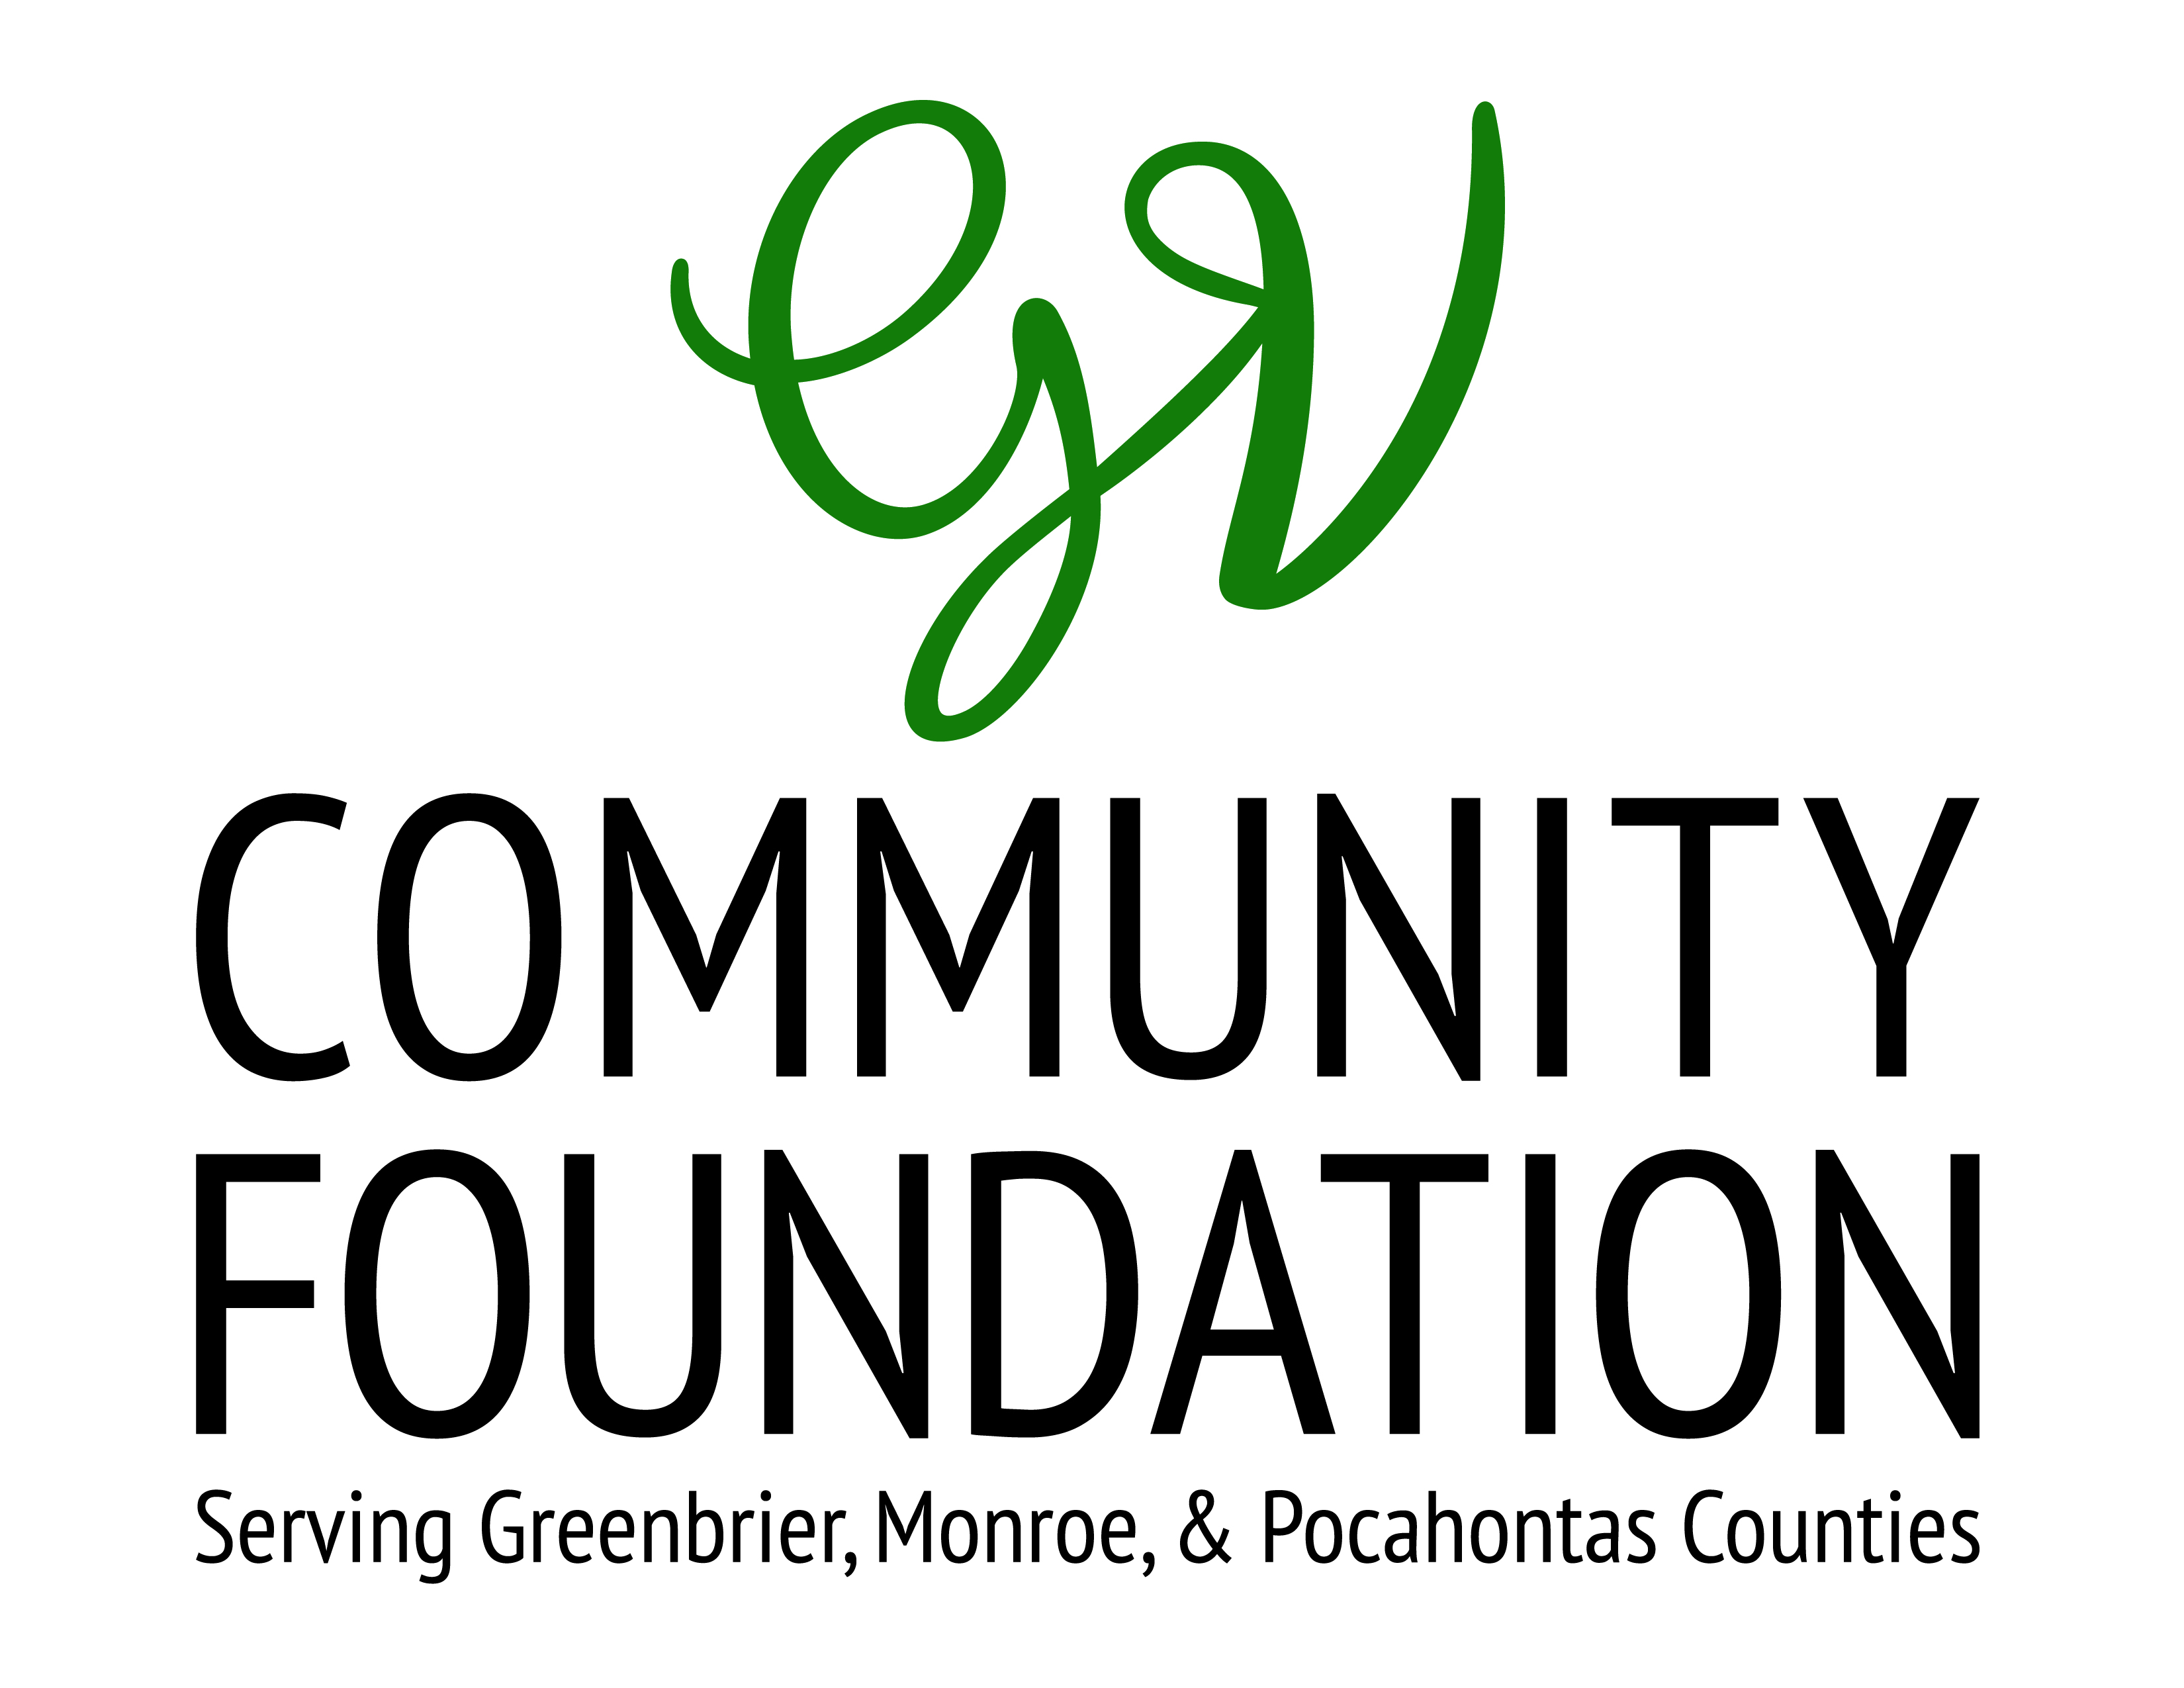

The Greenbrier Valley Community Foundation

2020-2021 Mary B. Nickell Grant for Arts and Education Grant

General Information

- What is the Greenbrier Valley Community Foundation Mary B. Nickell Grant?
The Mary B. Nickell Grant for Arts and Education was established to provide funding for enrichment programs in art in the Greenbrier County public schools. It provides up to $2,000.00 for projects to be completed in the upcoming school year. It may be used to purchase art supplies, pay honoraria for guest artists, and assist with the cost of travel and admission for student field trips as well as other educational purposes.

- Who is eligible to apply?
Art Teachers as well as any artists who would like to present an enrichment program in one of the public schools in Greenbrier County may apply. If the artist is not a public-school teacher, he/she must obtain the permission of a teacher to present the program in that teacher’s class. Each individual may submit two applications for different projects.

- What is the deadline to apply?
Applications must be received December 4, 2020 or June 4, 2021, emailed to info@gvfoundation.org.

- If I am awarded a grant, do I receive a check?
GVCF must make all of its grants to nonprofit organizations. Accordingly, a check will be written either to the school where the program is to be presented or, if the artist works with a nonprofit organization, the check may be written to them. These organizations will then make the appropriate allocations of funds.

THE GREENBRIER VALLEY COMMUNITY FOUNDATION
2020-2021 Mary B. Nickell Fund for Arts Education
Grant Application
Application Deadline: December 4, 2020 or June 4, 2021

GENERAL INFORMATION

Name: __________________________________________________________________

School: __________________________________________________________________

Address: _________________________________________________________________

________________________________________________________________________

Telephone: _________________________ Email: _______________________________

GRANT REQUEST INFORMATION

Name of Project: __________________________________________________________

Project Abstract (Brief summary of project – if your grant is selected, this will be used for public relations purposes):
________________________________________________________________________________________________________________________________________________________________________________________________________________________________________________________________________________________________________________________

Amount of this Request: $ ____________ (May not exceed $2,000)

Proposed beginning/ending dates of grant request: ___________________________________

Please email application forms to: info@gvfoundation.org

The mission of the Greenbrier Valley Community Foundation is to create a tradition of charitable giving and enhance the quality of life of the people of the Greenbrier Valley by accepting contributions, managing funds and making charitable distributions.

Mary B. Nickell Fund for Arts Education Grant Application
Page 2

Below or on one separate page, please describe your objectives for the project and the methods you will be using to achieve these goals.

Below or on one separate page, please provide a budget narrative detailing the program expenses including materials and supplies to be purchased.

ENDORSEMENT

We have carefully read the information provided for The Greater Greenbrier Valley Community Foundation (GVCF) Proposal Form. If we receive a grant, we agree to use the funds as granted. We will allow GVCF to use information provided in this request for public information pieces and will mention GVCF’s support in any publicity generated regarding the project.

__________________________________________________________ ___________________________________
Applicant Date

__________________________________________________________ ___________________________________
Sponsoring Teacher (if not applicant) Date

__________________________________________________________ ____________________________________
School Principal Date

